Rockbuster database

Rockbuster |

Data dictionary

2023

|  |  |
| --- | --- |
| **Rockbuster database:** | **Content** |

**Contents**

Entity Relationship Diagram 2

Entity Relationship Diagram 3

**DATA TABLE** 4

Rental 5

Payment 6

Film 7

Film actor 8

Actor 9

Inventory 10

Language 11

Film category 12

Category 13

Customer 14

Staff 15

Store 16

Address 17

City 18

Country 19

|  |
| --- |
| ROCKBUSTER DATABASE: **Entity Relationship Diagram** |

**ROCKBUSTER DATABASE:**

|  |  |
| --- | --- |
| Entity Relationship Diagram |  |

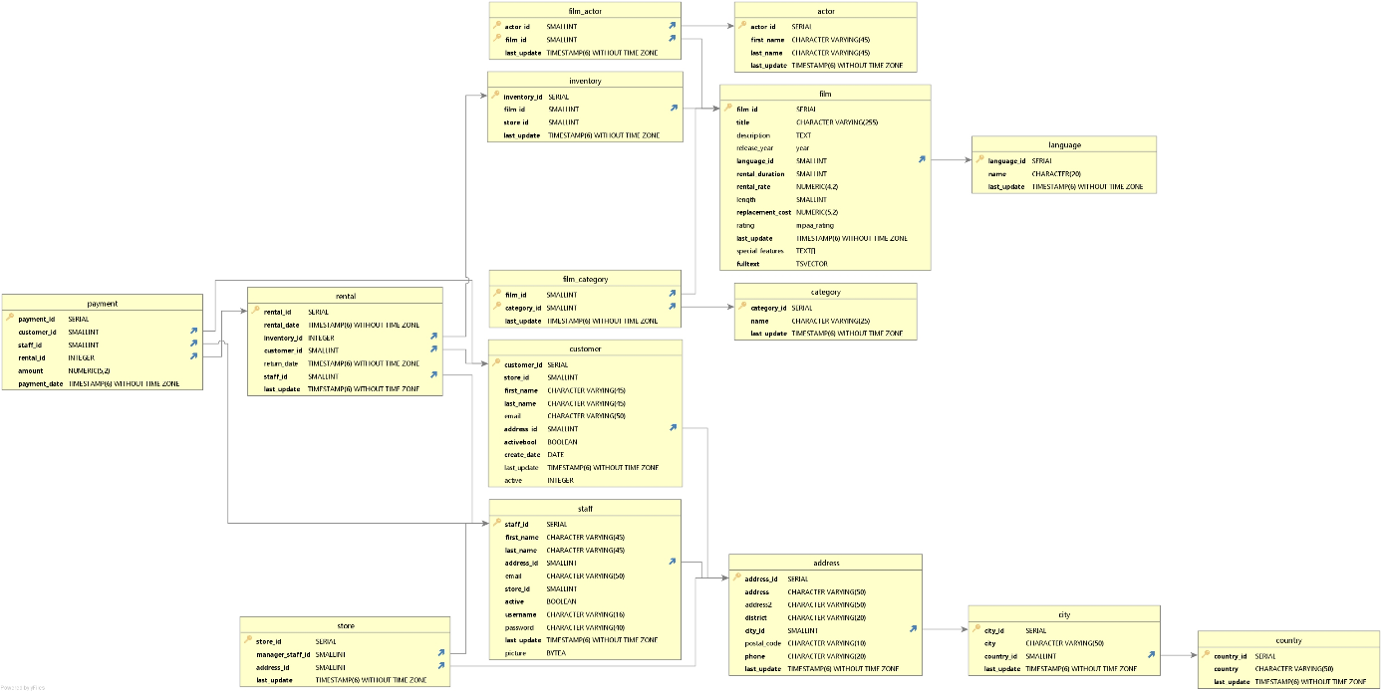

Figure 1: In this diagram we can see tables and relationships which exist within Rockbuster database

|  |
| --- |
| ROCKBUSTER DATABASE: **DATA TABLE** |

|  |  |
| --- | --- |
| Data tables: | Rental |

|  |  |  |
| --- | --- | --- |
| Columns | Data Type | Description |
| Key with solid fillRental_id | SERIAL | Unique ID for each rental event |
| Rental_date | TIMESTAMP(6) WITHOUT TIMEZONE | Time in which the event took place |
| Inventory_id | INTEGER | Unique ID of each item |
| Customer_id | SMALLINT | Unique ID to identify each customer |
| Return_date | TIMESTAMP(6) WITHOUT TIMEZONE | The date when each item has been returned |
| Staff_id | SMALLINT | Unique ID of the employee who processed the transaction |
| Last_update | TIMESTAMP(6) WITHOUT TIMEZONE | Time when the information was updated |
| Linked to | | |
| Table name | Join on: | |
| Inventory | Inventory_id | |
| Customer | Customer_id | |
| Staff | Staf_id | |
| Payment | Rental_id | |

|  |  |
| --- | --- |
| Data tables: | Payment |

|  |  |  |
| --- | --- | --- |
| Columns | Data Type | Description |
| Key with solid fillPayment_id | SERIAL | Unique ID of each transaction |
| Customer_id | SMALLINT | Unique ID to identify each customer |
| Staff_id | SMALLINT | Unique ID of the employee who processed the transaction |
| Rental_id | SERIAL | Unique ID for each rental event |
| Amount | NUMERIC(5,2) | Amount paid for rental |
| Payment_date | TIMESTAMP(6) WITHOUT TIMEZONE | The date when the payment occurred |
| Linked to: | | |
| Table name | Join on: | |
| Customer | Customer_id | |
| Staff | Staff_id | |
| Rental | Rental_id | |

|  |  |
| --- | --- |
| Data tables: | Film |

|  |  |  |
| --- | --- | --- |
| Columns | Data Type | Description |
| Key with solid fillFilm_id | SERIAL | Unique ID of the Item |
| Title | CHARACTER VARYING(255) | Title of the film |
| Description | TEXT | Film description |
| Release_year | YEAR | Release date of the film |
| Language_id | SMALLINT | Unique ID of language |
| Rental_duration | SMALLINT | Rental duration (why do we have it here?) |
| Rental_rate | NUMERIC(4,2) | Price for item’s rental |
| Length | SMALLINT | Film duration |
| Replacement_cost | NUMERIC(5,2) | The price which has to be paid in case of replacement |
| Rating | Mpaa_rating | Rating of the film |
| Last_update | TIMESTAMP(6) WITHOUT TIMEZONE | Time when the information in this table was updated last time |
| Special_features | TEXT[] | Description of special features of the film |
| Fulltext | TSVECTOR | Array of characteristics like recommended age, genre, keywords |
| Linked to: | | |
| Table name | Join on: | |
| Language | Language_id | |
| Film_category | Film_id | |
| Inventory | Film_id | |
| Film_actor | Film_id | |

|  |  |
| --- | --- |
| Data tables: | Film actor |

|  |  |  |
| --- | --- | --- |
| Columns | Data Type | Description |
| Key with solid fillActor_id | SMALLINT | Unique ID of the actor |
| Key with solid fillFilm_id | SMALLINT | Unique ID of film |
| Last_update | TIMESTAMP(6) WITHOUT TIMEZONE | Time when the information in this table was updated last time |
| Linked to: | | |
| Table name | Join on | |
| Actor | Actor_id | |
| Film | Film_id | |

|  |  |
| --- | --- |
| Data tables: | Actor |

|  |  |  |
| --- | --- | --- |
| Columns | Data Type | Description |
| Key with solid fillActor_id | SERIAL | Unique ID of the actor |
| First_name | CHARACTER VARYING(45) | Actor’s first name |
| Last_name | CHARACTER VARYING(45) | Actor’s last name |
| Last_update | TIMESTAMP(6) WITHOUT TIMEZONE | Time when the information in this table was updated last time |
| Linked to | | |
| Table | Join on | |
| Film actor | Actor_id | |

|  |  |
| --- | --- |
| Data tables: | Inventory |

|  |  |  |
| --- | --- | --- |
| Columns | Data Type | Description |
| Key with solid fillInventory_id | SERIAL | ID of each item |
| Film_id | SMALLINT | Unique ID of the film (item) |
| Last_update | TIMESTAMP(6) WITHOUT TIMEZONE | Time when the information in this table was updated last time |
| Linked to | | |
| Table | Join on | |
| Film | Film_id | |
| Rental | Inventory_id | |

|  |  |
| --- | --- |
| Data tables: | Language |

|  |  |  |
| --- | --- | --- |
| Columns | Data Type | Description |
| Key with solid fillLanguage_id | SERIAL | Unique ID for language category |
| Name | CHARACTER(20) | Name of the language |
| Last_update | TIMESTAMP(6) WITHOUT TIMEZONE | Time when the information in this table was updated last time |
| Linked to | | |
| Table | Join on | |
| Film | Language_id | |

|  |  |
| --- | --- |
| Data tables: | Film category |

|  |  |  |
| --- | --- | --- |
| Columns | Data Type | Description |
| Key with solid fillFilm_id | SMALLINT | Unique ID of the film |
| Key with solid fillCategory_id | SMALLINT | Unique ID of category |
| Last_update | TIMESTAMP(6) WITHOUT TIMEZONE | Time when the information in this table was updated last time |
| Linked to: | | |
| Table | Join on | |
| Film | Film_id | |
| Category | Category_id | |

|  |  |
| --- | --- |
| Data tables: | Category |

|  |  |  |
| --- | --- | --- |
| Columns | Data Type | Description |
| Key with solid fillCategory_id | SERIAL | Unique ID for category |
| Name | CHARACTER VARYING(25) | Name of category |
| Last_update | TIMESTAMP(6) WITHOUT TIMEZONE | Time when the information in this table was updated last time |
| Linked to: | | |
| Table | Join on | |
| Film_category | Category_id | |

|  |  |
| --- | --- |
| Data tables: | Customer |

|  |  |  |
| --- | --- | --- |
| Columns | Data Type | Description |
| Key with solid fillCustomer_id | SERIAL | Unique ID of the customer |
| Store_id | SMALLINT | Unique ID of each store |
| First_name | CHARACTER VARYING(45) | First name of the customer |
| Last_name | CHARACTER VARYING(45) | Last name of the customer |
| Email | CHARACTER VARYING(50) | Email address of the customer |
| Address_id | SMALLINT | Unique id for address. |
| Activebool | BOOLEAN | Describes with yes/no answer whether the address is active or not |
| Create_date | DATE | Date the address was created |
| Last_update | TIMESTAMP(6) WITHOUT TIMEZONE | Time when the information in this table was updated last time |
| Active | INTEGER | Numeric expression of activebool. |
| Linked to: | | |
| Table | Join on | |
| Rental | Customer_id | |
| Address | Address_id | |
| Payment | Customer_iD | |

|  |  |
| --- | --- |
| Data tables: | Staff |

|  |  |  |
| --- | --- | --- |
| Columns | Data Type | Description |
| Key with solid fillStaff_id | SERIAL | Unique ID of the employee |
| First_name | CHARACTER VARYING(45) | First name of the employee |
| Last_name | CHARACTER VARYING(45) | Last name of the employee |
| Address_id | SMALLINT | Unique id for address |
| Email | CHARACTER VARYING(50) | Email address of the customer |
| Store_id | SMALLINT | Unique ID of the store |
| Activebool | BOOLEAN | Describes with yes/no answer whether the address is active or not |
| Username | CHARACTER VARYING(16) | User name of the employee |
| Password | CHARACTER VARYING(40) | Password of the employee |
| Last_update | TIMESTAMP(6) WITHOUT TIMEZONE | Time when the information in this table was updated last time |
| Picture | BYTEA | Picture of the employee |
| Linked to: | | |
| Table | Join on | |
| Payment | Staff_id | |
| Address | Address_id | |
| Rental | Staff_id | |
| Store | Staff_id | |

|  |  |
| --- | --- |
| Data tables: | Store |

|  |  |  |
| --- | --- | --- |
| Columns | Data Type | Description |
| Key with solid fillStore_id | SERIAL | Unique ID of the store |
| Manager_staff_id | SMALLINT | Unique ID of the manager |
| Address_id | SMALLINT | Unique ID of address |
| Last_update | TIMESTAMP(6) WITHOUT TIMEZONE | Time when the information in this table was updated last time |
| Linked to: | | |
| Table | Join on | |
| Staff | Manager_staff_id | |
| Address | Address_id | |

|  |  |
| --- | --- |
| Data tables: | Address |

|  |  |  |
| --- | --- | --- |
| Columns | Data Type | Description |
| Key with solid fillAddress_id | SERIAL | Unique ID of address |
| Address | CHARACTER VARYING(50) | Street, house nr, apartment |
| Address2 | CHARACTER VARYING(50) | Additional info |
| District | CHARACTER VARYING(20) | District |
| City_id | SMALLINT | Unique id of the city |
| Postal_code | CHARACTER VARYING(10) | Postal code |
| Phone | CHARACTER VARYING(20) | Phone number of the customer |
| Last_update | TIMESTAMP(6) WITHOUT TIMEZONE | Time when the information in this table was updated last time |
| Linked to: | | |
| Table | Join on | |
| Store | Address_id | |
| City | City_id | |
| Customer | Address_id | |
| Staff | Staff_id | |
| Stora | Store_id | |

|  |  |
| --- | --- |
| Data tables: | City |

|  |  |  |
| --- | --- | --- |
| Columns | Data Type | Description |
| Key with solid fillCity_id | SERIAL | Unique id of the city |
| City | CHARACTER VARYING(50) | Name of the city |
| Country_id | SMALLINT | Unique id of the country |
| Last_update | TIMESTAMP(6) WITHOUT TIMEZONE | Time when the information in this table was updated last time |
| Linked to | | |
| Table | Join on | |
| Address | City_id | |
| Country | Country_id | |

|  |  |
| --- | --- |
| Data tables: | Country |

|  |  |  |
| --- | --- | --- |
| Columns | Data Type | Description |
| Key with solid fillCountry_id | SERIAL | Unique id of the country |
| Country | CHARACTER VARYING(50) | Name of the country |
| Last_update | TIMESTAMP(6) WITHOUT TIMEZONE | Time when the information in this table was updated last time |
| Linked to | | |
| Table | Join on | |
| City | Country_id | |